Lab Manual 5: Introduction to Wireshark

Packet Capturing and Analyzing Real-time HTTP Traffic, Proxy Server, and Web Server
Course: Computer Networks Lab
Duration: 3 Hours
Difficulty Level: Beginner to Intermediate
CLO : 2

Table of Contents
- Lab Objectives
- Prerequisites
- Required Software and Tools
- Theoretical Background
- Lab Setup
- Part 1: Introduction to Wireshark Interface
- Part 2: Capturing HTTP Traffic (Direct Web Server)
- Part 3: Setting Up and Analyzing Proxy Server Traffic
- Part 4: Setting Up Local Web Server
- Lab Tasks
- Home Assignment
- Submission Guidelines

Lab Objectives
By the end of this lab, students will be able to:
- Understand the basics of packet capturing using Wireshark
- Identify and analyze HTTP protocol packets in network traffic
- Differentiate between HTTP requests and responses
- Understand the role of proxy servers in network communication
- Capture and analyze traffic between client, proxy server, and web server
- Set up a basic local web server and analyze its traffic
- Apply display filters in Wireshark for targeted packet analysis
- Extract useful information from captured packets

Prerequisites
- Basic understanding of computer networks
- Familiarity with TCP/IP protocol suite
- Basic knowledge of HTTP protocol
- Administrator/root access to the computer
- Active internet connection

Required Software and Tools

Software to Install:
- Wireshark (Latest Version)
  - Download from: https://www.wireshark.org/download.html
  - Install with administrative privileges
- Web Browser (Any modern browser)
  - Google Chrome, Firefox, or Edge
- Local Web Server (Choose one):
  - XAMPP (Recommended for Windows) - https://www.apachefriends.org/
  - Python (Built-in HTTP server) - Already available on most systems
  - Node.js with http-server package
- Proxy Server Software (Choose one):
  - Squid Proxy (Linux/Windows)
  - CCProxy (Windows) - http://www.ccproxy.com/
  - Burp Suite Community Edition (Cross-platform)
  - Python proxy script (Provided in lab)

Theoretical Background

What is Wireshark?
Wireshark is a free and open-source packet analyzer used for network troubleshooting, analysis, software and communications protocol development, and education. It captures network packets in real-time and displays them in a human-readable format.

HTTP Protocol Overview
HTTP (Hypertext Transfer Protocol) is an application-layer protocol used for transmitting hypermedia documents, such as HTML. It follows a client-server model:
- Client (Browser) sends HTTP Request
- Server (Web Server) sends HTTP Response
HTTP Methods:
- GET: Retrieve data from server
- POST: Send data to server
- PUT: Update data on server
- DELETE: Remove data from server
HTTP Status Codes:
- 200: OK (Success)
- 404: Not Found
- 500: Internal Server Error
- 301/302: Redirect

Proxy Server
A proxy server acts as an intermediary between a client and a server. Traffic flow with proxy:
Client → Proxy Server → Web Server
Client ← Proxy Server ← Web Server
Types of Proxies:
- Forward Proxy: Serves clients (hides client IP)
- Reverse Proxy: Serves servers (load balancing, caching)
Benefits:
- Anonymity and privacy
- Content filtering
- Caching for performance
- Access control and logging

Web Server
A web server is software that serves web pages to clients upon request. Popular web servers include:
- Apache HTTP Server
- Nginx
- Microsoft IIS
- Python HTTP Server

Lab Setup

Step 1: Install Wireshark
For Windows:
- Download Wireshark installer from official website
- Run the installer with administrative privileges
- During installation, install Npcap (packet capture library) when prompted
- Complete the installation and restart if required
For Linux (Ubuntu/Debian):
sudo apt update
sudo apt install wireshark
sudo usermod -aG wireshark $USER
Log out and log back in for group changes to take effect.
For macOS:
- Download the DMG file from Wireshark website
- Install by dragging to Applications folder
- Install ChmodBPF for packet capture

Step 2: Verify Wireshark Installation
- Open Wireshark
- You should see a list of network interfaces
- If no interfaces appear, check your installation and permissions

Part 1: Introduction to Wireshark Interface

Step 1: Launch Wireshark
- Open Wireshark with administrative/root privileges
- Observe the main window with three sections:
  - Interface List: Shows available network interfaces
  - Capture Options: Buttons to start/stop capture
  - Welcome Screen: Recent captures and learning resources
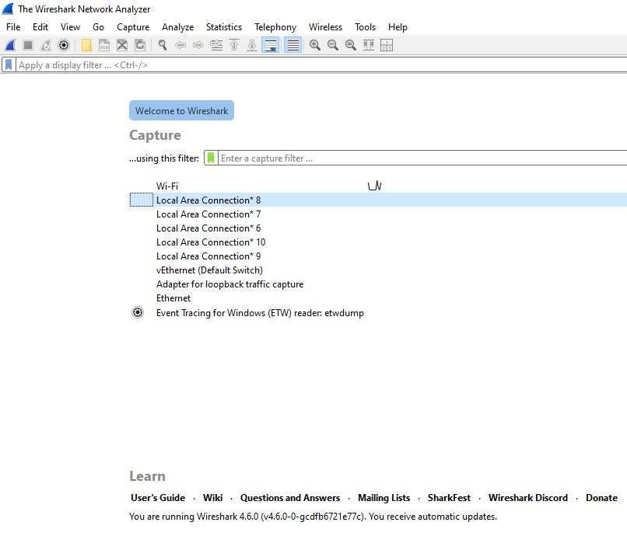

Step 2: Understanding the Interface
Once you start capturing (we'll do this soon), Wireshark displays three panes:
- Packet List Pane (Top): Shows all captured packets
  - Columns: No., Time, Source, Destination, Protocol, Length, Info
- Packet Details Pane (Middle): Shows detailed protocol information
  - Expandable tree structure
  - Shows protocol layers (Ethernet → IP → TCP → HTTP)
- Packet Bytes Pane (Bottom): Shows raw hexadecimal data
  - Left side: Hex values
  - Right side: ASCII representation

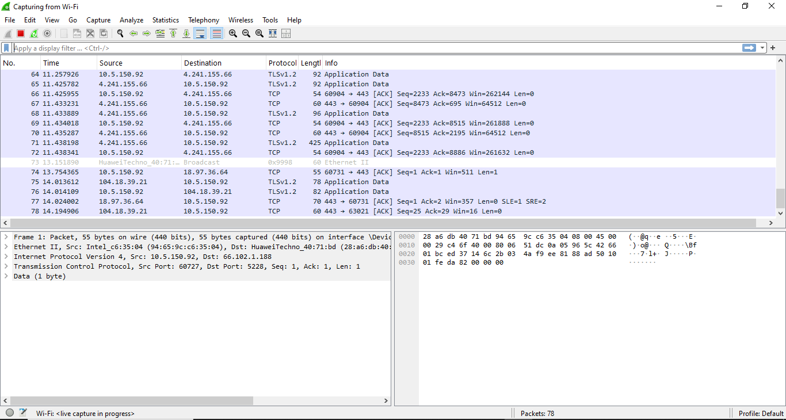
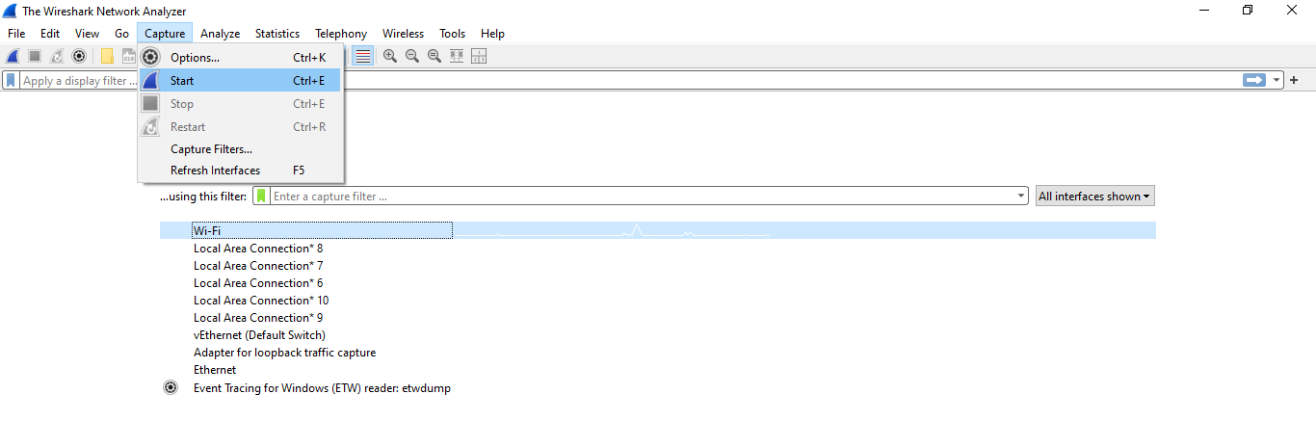

Step 3: Select Network Interface
- Identify your active network interface:
  - WiFi users: Look for "Wi-Fi" or "WLAN"
  - Ethernet users: Look for "Ethernet" or "eth0"
  - The interface showing activity (wavy line graph) is likely your active one
- Double-click on your active interface to start capturing

Step 4: Stop and Clear
- Click the red Stop button (square icon) to stop capturing
- Click File → Close to close this capture
- We'll start fresh in the next section

Part 2: Capturing HTTP Traffic (Direct Web Server)

Step 1: Start Packet Capture
- Open Wireshark
- Select your active network interface
- Click the blue Start button (shark fin icon)
- Packets will start appearing immediately

Step 2: Generate HTTP Traffic
Since most websites now use HTTPS (encrypted), we need to find an HTTP site for this exercise.
- Open your web browser
- Visit the following HTTP (not HTTPS) website:
  - http://example.com
  - http://info.cern.ch
  - http://neverssl.com
- Navigate through a few pages to generate traffic
Note: If you see a warning about unsecure connection, proceed anyway (only for this lab exercise).

Step 3: Apply HTTP Display Filter
Wireshark captures ALL network traffic, so we need to filter for HTTP only.
- In the display filter bar (top of Wireshark window), type:
- http
- Press Enter or click the arrow button
- You should now see only HTTP packets
Observation: Notice how the packet list becomes much smaller. This is the power of filtering!

Step 4: Analyze HTTP Request
- Look for a packet with Info column showing "GET" (HTTP request)
- Click on that packet to select it
- In the Packet Details Pane, expand the following:
  - Hypertext Transfer Protocol
  - Look for these fields:
    - Request Method: GET
    - Request URI: The page you requested (e.g., /)
    - Host: The domain name
    - User-Agent: Your browser information
- Expand "GET / HTTP/1.1" to see full request details
Record the following information:
- Request Method: ___________
- Host: ___________
- Request URI: ___________
- User-Agent: ___________

Step 5: Analyze HTTP Response
- Look for the next packet with Info showing "HTTP/1.1 200 OK" (HTTP response)
- This is the server's response to your request
- In the Packet Details Pane, expand:
  - Hypertext Transfer Protocol
  - Look for:
    - Status Code: 200 (or other codes)
    - Content-Type: Type of content (text/html, image/jpeg, etc.)
    - Content-Length: Size of response
    - Server: Web server software information
Record the following:
- Status Code: ___________
- Content-Type: ___________
- Server: ___________

Step 6: View HTTP Content
- Right-click on the HTTP response packet
- Select Follow → HTTP Stream
- A new window opens showing the entire HTTP conversation:
  - Red text: Client request
  - Blue text: Server response
- You can see the actual HTML content sent by the server

Step 7: Export HTTP Objects
- Go to File → Export Objects → HTTP
- A window shows all HTTP objects (images, pages, CSS, etc.) from your capture
- Select any object and click Save to export it
- This demonstrates how data is transmitted over the network

Step 8: Save Your Capture
- Click the Stop button to stop capturing
- Go to File → Save As
- Save the file as: http_direct_capture.pcapng
- This file contains all captured packets for later analysis

Part 3: Setting Up and Analyzing Proxy Server Traffic

Step 1: Set Up a Simple Proxy Server
We'll use a Python-based proxy server for simplicity.
Option A: Using Python (Recommended)
- Create a file named simple_proxy.py with the following code:
import socket
import threading

def handle_client(client_socket):
# Receive request from client
request = client_socket.recv(4096)

# Parse the request
first_line = request.split(b'\n')[0]
url = first_line.split(b' ')[1]

# Find the webserver and port
http_pos = url.find(b'://')
if http_pos == -1:
temp = url
else:
temp = url[(http_pos+3):]

port_pos = temp.find(b':')
webserver_pos = temp.find(b'/')

if webserver_pos == -1:
webserver_pos = len(temp)

webserver = ""
port = -1

if port_pos == -1 or webserver_pos < port_pos:
port = 80
webserver = temp[:webserver_pos]
else:
port = int((temp[(port_pos+1):])[:webserver_pos-port_pos-1])
webserver = temp[:port_pos]

try:
# Create socket to connect to webserver
s = socket.socket(socket.AF_INET, socket.SOCK_STREAM)
s.connect((webserver.decode(), port))
s.send(request)

while True:
# Receive data from webserver
data = s.recv(4096)
if len(data) > 0:
# Send to client
client_socket.send(data)
else:
break
s.close()
client_socket.close()
except Exception as e:
print(f"Error: {e}")
client_socket.close()

def start_proxy(port=8888):
server = socket.socket(socket.AF_INET, socket.SOCK_STREAM)
server.bind(('localhost', port))
server.listen(5)
print(f"[*] Proxy server listening on localhost:{port}")

while True:
client_socket, addr = server.accept()
print(f"[*] Accepted connection from {addr[0]}:{addr[1]}")
client_handler = threading.Thread(target=handle_client, args=(client_socket,))
client_handler.start()

if __name__ == '__main__':
start_proxy()
- Save the file
- Open terminal/command prompt in the same directory
- Run the proxy server:
- python simple_proxy.py
- You should see: [*] Proxy server listening on localhost:8888
Option B: Using CCProxy (Windows)
- Download CCProxy from http://www.ccproxy.com/
- Install and launch CCProxy
- Note the proxy port (default: 808)
- Click "Start" to run the proxy server

Step 2: Configure Browser to Use Proxy
For Google Chrome/Edge:
- Open browser settings
- Search for "proxy" in settings
- Click "Open your computer's proxy settings"
- Under "Manual proxy setup", turn on "Use a proxy server"
- Enter:
  - Address: localhost or 127.0.0.1
  - Port: 8888 (or your proxy port)
- Click "Save"
For Firefox:
- Open Firefox Settings
- Scroll to "Network Settings"
- Click "Settings"
- Select "Manual proxy configuration"
- Enter:
  - HTTP Proxy: localhost
  - Port: 8888
- Click "OK"

Step 3: Start Wireshark Capture
- Start a new Wireshark capture on your active interface
- Apply the display filter:
- http or tcp.port == 8888
- This filter shows HTTP traffic and any traffic on your proxy port

Step 4: Generate Traffic Through Proxy
- With proxy configured, visit the same HTTP websites:
  - http://example.com
  - http://neverssl.com
- Observe Wireshark capturing packets

Step 5: Analyze Proxy Traffic Flow
- In Wireshark, look at the Source and Destination columns
- You should see traffic flowing in this pattern:
  - Client IP → 127.0.0.1 (Proxy): Client sends request to proxy
  - 127.0.0.1 (Proxy) → Web Server IP: Proxy forwards request to server
  - Web Server IP → 127.0.0.1 (Proxy): Server responds to proxy
  - 127.0.0.1 (Proxy) → Client IP: Proxy forwards response to client
- Apply filter to see only proxy communication:
- ip.addr == 127.0.0.1

Step 6: Compare Direct vs Proxy Traffic
- Open your previous capture file: http_direct_capture.pcapng
- Compare with current proxy capture
- Notice the differences:
  - Direct: Client IP ↔ Server IP (2 parties)
  - Proxy: Client IP ↔ Proxy IP ↔ Server IP (3 parties)

Step 7: Analyze TCP Three-Way Handshake
- Remove all display filters (clear the filter box)
- Apply new filter:
- tcp.flags.syn == 1
- This shows TCP connection establishment packets (SYN, SYN-ACK, ACK)
- Observe how connections are established to the proxy, then from proxy to server

Step 8: Save Proxy Capture
- Stop the capture
- Save as: http_proxy_capture.pcapng
- Disable the proxy in your browser settings (reverse the configuration steps)

Part 4: Setting Up Local Web Server

Step 1: Set Up Local Web Server
Option A: Python HTTP Server (Simplest)
- Create a folder named webserver_test on your desktop
- Inside this folder, create a file named index.html:
<!DOCTYPE html>
<html>
<head>
<title>My Local Web Server</title>
<style>
body {
font-family: Arial, sans-serif;
text-align: center;
padding: 50px;
background-color: #f0f0f0;
}
h1 {
color: #333;
}
.info {
background-color: white;
padding: 20px;
border-radius: 10px;
margin: 20px auto;
max-width: 600px;
box-shadow: 0 2px 5px rgba(0,0,0,0.1);
}
</style>
</head>
<body>
<h1>Welcome to My Local Web Server!</h1>
<div class="info">
<h2>Server Information</h2>
<p>This page is served from your local machine.</p>
<p>Server Time: <span id="time"></span></p>
</div>
<script>
document.getElementById('time').textContent = new Date().toLocaleString();
</script>
</body>
</html>
- Open terminal/command prompt in the webserver_test folder
- Run:
- # For Python 3
- python -m http.server 8080

- # For Python 2
- python -m SimpleHTTPServer 8080
- You should see: Serving HTTP on 0.0.0.0 port 8080
Option B: Using XAMPP
- Install XAMPP from https://www.apachefriends.org/
- Launch XAMPP Control Panel
- Start the "Apache" module
- Place your HTML files in: C:\xampp\htdocs\ (Windows) or /opt/lampp/htdocs/ (Linux)

Step 2: Test Your Web Server
- Open your web browser
- Navigate to: http://localhost:8080 (or http://localhost for XAMPP)
- You should see your web page

Step 3: Capture Local Web Server Traffic
- Start Wireshark capture
- Apply filter:
- http and ip.addr == 127.0.0.1
- In your browser, access: http://localhost:8080
- Refresh the page several times
- Try accessing: http://127.0.0.1:8080

Step 4: Analyze Loopback Traffic
- Observe packets in Wireshark
- Notice:
  - Source and Destination both show 127.0.0.1 (loopback address)
  - This traffic never leaves your computer
  - Packets are processed by the OS network stack
- Click on an HTTP GET request
- Examine the packet details as done in Part 2

Step 5: Analyze Different HTTP Requests
- Create additional pages in your web server folder:
page2.html:
<!DOCTYPE html>
<html>
<head><title>Page 2</title></head>
<body>
<h1>Second Page</h1>
<p>This is another page on the local server.</p>
<a href="index.html">Back to Home</a>
</body>
</html>
- In Wireshark, continue capturing
- Navigate to: http://localhost:8080/page2.html
- In Wireshark, observe the different Request URIs for different pages

Step 6: Simulate Form Submission (POST Request)
- Create a form page named form.html:
<!DOCTYPE html>
<html>
<head><title>Test Form</title></head>
<body>
<h1>Test Form</h1>
<form action="http://httpbin.org/post" method="POST">
<label>Name: <input type="text" name="username"></label><br>
<label>Email: <input type="email" name="email"></label><br>
<button type="submit">Submit</button>
</form>
</body>
</html>
- Access: http://localhost:8080/form.html
- Fill out the form and submit
- In Wireshark, apply filter:
- http.request.method == "POST"
- Find the POST request packet
- Examine the packet details to see the form data being sent

Step 7: Save Local Server Capture
- Stop the capture
- Save as: http_localserver_capture.pcapng

Lab Tasks
Complete the following tasks and document your findings:

Task 1: HTTP Method Identification (15 minutes)
- Visit http://neverssl.com and browse different pages
- Capture traffic and identify at least 3 different HTTP requests
- For each request, document:
  - Request Method (GET, POST, etc.)
  - Request URI
  - Host header
  - User-Agent
- Take screenshots of your findings

Task 2: HTTP Status Code Analysis (15 minutes)
- Try to access a non-existent page: http://example.com/thispagедoesnotexist
- Capture and find the HTTP response
- Identify the status code (should be 404)
- Find at least 2 other different status codes by visiting various pages
- Document what each status code means

Task 3: Proxy Server Traffic Comparison (20 minutes)
- Capture traffic accessing http://info.cern.ch WITHOUT proxy
- Save the capture file
- Configure your proxy and capture traffic accessing the SAME website
- Save this capture file
- Compare both captures and document:
  - Number of packets in each capture
  - Source/Destination IP addresses
  - Time taken for page load (compare timestamps)
  - Any differences in HTTP headers

Task 4: Content Extraction (15 minutes)
- Visit a website with images over HTTP
- Use Wireshark's "Export Objects → HTTP" feature
- Extract at least 3 different object types (HTML, image, CSS/JS)
- Document:
  - File names extracted
  - File sizes
  - Content types
  - Which HTTP response contained each object

Task 5: TCP Analysis (20 minutes)
- Start a fresh capture
- Access your local web server: http://localhost:8080
- Apply filter: tcp.port == 8080
- Identify and document:
  - Three-way handshake packets (SYN, SYN-ACK, ACK)
  - Sequence and Acknowledgment numbers
  - Window size
  - Total number of TCP packets for one HTTP transaction

Task 6: Display Filters Practice (15 minutes)
Practice using the following Wireshark display filters and document what each shows:
http.request.method == "GET"
http.response.code == 200
http.host == "example.com"
http.content_type contains "text"
http.request.uri contains "index"
tcp.port == 80 and http
For each filter, capture a screenshot and explain what packets are displayed.

Task 7: Traffic Statistics (10 minutes)
- Open one of your capture files
- Go to Statistics → Protocol Hierarchy
- Document:
  - Percentage of HTTP traffic
  - Percentage of TCP traffic
  - Total packets captured
  - Total bytes captured
- Go to Statistics → HTTP → Requests
- Document the top 5 most requested URLs

Home Assignment
Due Date: [Instructor to specify]

Assignment 1: Website Traffic Analysis
- Choose any THREE websites that support HTTP (not HTTPS):
  - Use http://neverssl.com for reference to find more HTTP sites
- For each website:
  - Capture at least 2 minutes of browsing traffic
  - Save the capture file with a descriptive name
  - Analyze and document:
    - Total number of HTTP requests
    - Different types of HTTP methods used
    - Different status codes received
    - Types of content received (HTML, images, CSS, JS, etc.)
    - At least 5 different HTTP headers and their purposes
- Create a comparison table for all three websites

Assignment 2: Proxy Server Investigation
- Research and write a 2-page report on:
  - Types of proxy servers (Forward, Reverse, Transparent)
  - Real-world applications of proxy servers
  - Security implications of using proxy servers
  - Popular proxy server software (Squid, Nginx, HAProxy)
  - Privacy concerns with proxies
- Include diagrams showing traffic flow for each proxy type

Assignment 3: Advanced Wireshark Filters
- Research and test 10 advanced Wireshark display filters not covered in the lab
- For each filter:
  - Write the filter syntax
  - Explain what it does
  - Provide a screenshot showing the filter in action
  - Explain a practical use case
Examples to explore:
- Filtering by packet size
- Filtering by time ranges
- Combining multiple conditions with AND/OR
- Using "contains" and "matches" operators
- Filtering TCP flags

Assignment 4: HTTP Security Analysis
- Compare HTTP and HTTPS traffic:
  - Capture traffic for an HTTP website
  - Capture traffic for an HTTPS website (you'll see encrypted data)
  - Document the differences
  - Explain why HTTPS is more secure
- Demonstrate:
  - How plaintext passwords can be seen in HTTP traffic
  - What information is visible in HTTPS traffic
  - Write recommendations for secure web browsing

Assignment 5: Local Web Server Deployment
- Set up a complete local web server with:
  - At least 5 HTML pages with navigation
  - A contact form (use POST method)
  - At least 3 images
  - CSS styling
- Capture and analyze traffic for:
  - Loading the home page
  - Navigating between pages
  - Submitting the form
  - Loading images
- Document:
  - Complete HTTP transaction for each action
  - All HTTP headers sent and received
  - Content types for different resources
  - Timing analysis (how long each request took)

Assignment 6: Research Report
Write a 3-4 page report on ONE of the following topics:
- Evolution of HTTP Protocol
  - HTTP/1.0, HTTP/1.1, HTTP/2, HTTP/3
  - Key differences and improvements
  - Performance comparisons
- Web Caching Mechanisms
  - How caching works in HTTP
  - Cache-Control headers
  - Benefits and challenges
  - Proxy caching vs browser caching
- Load Balancing and Reverse Proxies
  - How load balancers work
  - Common load balancing algorithms
  - Role of reverse proxies
  - Case studies (Nginx, HAProxy)

Submission Guidelines

Lab Report Format
Your lab report should include:
- Cover Page
  - Lab title
  - Your name and student ID
  - Date of submission
  - Course name and section
- Table of Contents
- Introduction
  - Brief overview of the lab objectives
  - Tools and software used
- Lab Tasks Documentation
  - For each task:
    - Task description
    - Procedure followed
    - Screenshots with annotations
    - Observations and findings
    - Answers to questions
- Home Assignment Solutions
  - Complete solutions for all assignments
  - Include all required documentation, tables, and reports
- Conclusion
  - Summary of what you learned
  - Challenges faced and how you overcame them
  - Practical applications of the skills learned
- References
  - List any resources used

Submission Requirements
- Submit as a single PDF file
- Include all PCAPNG capture files in a ZIP archive
- File naming convention:
  - Report: StudentID_NetworkLab_Week#.pdf
  - Captures: StudentID_CaptureFiles.zip
- Ensure all screenshots are clear and properly labeled
- Code/configuration files should be formatted properly
- Submission deadline: [Instructor to specify]

Grading Rubric
- Lab Tasks Completion (40%)
  - All tasks completed correctly
  - Proper documentation and screenshots
  - Clear observations and analysis
- Home Assignments (40%)
  - Quality and depth of research
  - Completeness of analysis
  - Clarity of explanations
  - Proper use of technical terminology
- Report Quality (10%)
  - Professional formatting
  - Clear writing and organization
  - Proper citations and references
- Technical Understanding (10%)
  - Demonstration of concepts learned
  - Ability to analyze and interpret results
  - Critical thinking in observations

Additional Resources

Wireshark Learning Resources
- Official Wireshark User Guide: https://www.wireshark.org/docs/wsug_html_chunked/
- Wireshark Display Filter Reference: https://www.wireshark.org/docs/dfref/
- Wireshark Wiki: https://wiki.wireshark.org/

HTTP Protocol Resources
- MDN Web Docs - HTTP: https://developer.mozilla.org/en-US/docs/Web/HTTP
- RFC 2616 - HTTP/1.1 Specification: https://tools.ietf.org/html/rfc2616
- HTTP Status Codes: https://httpstatuses.com/

Networking Basics
- Cisco Networking Basics: https://www.cisco.com/c/en/us/solutions/small-business/resource-center/networking/networking-basics.html
- TCP/IP Guide: http://www.tcpipguide.com/

Video Tutorials
- Wireshark Tutorial for Beginners (YouTube)
- HTTP Protocol Explained (YouTube)
- Proxy Servers Explained (YouTube)

Troubleshooting Common Issues

Issue 1: Wireshark Shows No Packets
Solutions:
- Check if you selected the correct network interface
- Ensure you have administrator/root privileges
- Check if your antivirus/firewall is blocking Wireshark
- Try restarting Wireshark

Issue 2: Cannot Find HTTP Traffic
Solutions:
- Verify you're visiting HTTP sites (not HTTPS)
- Check your display filter syntax
- Clear all filters temporarily to see all traffic
- Ensure your browser isn't forcing HTTPS

Issue 3: Proxy Server Not Working
Solutions:
- Verify proxy is running (check terminal/application)
- Confirm correct proxy address and port in browser settings
- Try accessing a simple HTTP site first
- Check firewall settings
- Restart proxy server and browser

Issue 4: Local Web Server Not Accessible
Solutions:
- Verify server is running (check terminal)
- Confirm correct port number (default: 8080)
- Try both localhost and 127.0.0.1
- Check if port is blocked by firewall
- Ensure no other application is using the same port

Issue 5: Cannot See Loopback Traffic
Solutions:
- Windows: Install Npcap with "loopback support" option
- Linux: Capture on "lo" interface
- Try using different capture interface options
- Update Wireshark to latest version

Safety and Ethical Considerations
- Legal Compliance
  - Only capture traffic on networks you own or have permission to monitor
  - Do not intercept or analyze others' network traffic without authorization
  - Be aware of local laws regarding network monitoring
- Privacy
  - Do not share captured traffic containing sensitive information
  - Be cautious when handling captured credentials or personal data
  - Use lab environments for practice, not production networks
- Security
  - Disable proxy settings after lab completion
  - Do not use captured credentials for unauthorized access
  - Secure your capture files as they may contain sensitive data
- Best Practices
  - Always get permission before monitoring network traffic
  - Use isolated lab environments when possible
  - Keep Wireshark and related tools updated
  - Follow your institution's acceptable use policy

Quick Reference Guide

Common Wireshark Display Filters
# Protocol Filters
http # Show only HTTP traffic
tcp # Show only TCP traffic
udp # Show only UDP traffic
dns # Show only DNS traffic

# HTTP Specific Filters
http.request # Show HTTP requests only
http.response # Show HTTP responses only
http.request.method == "GET" # Show only GET requests
http.request.method == "POST" # Show only POST requests
http.response.code == 200 # Show only 200 OK responses
http.response.code == 404 # Show only 404 Not Found
http.host == "example.com" # Filter by hostname
http.request.uri contains "login" # URI contains "login"

# IP Address Filters
ip.addr == 192.168.1.1 # Traffic to/from this IP
ip.src == 192.168.1.1 # Traffic from this IP
ip.dst == 192.168.1.1 # Traffic to this IP

# Port Filters
tcp.port == 80 # Traffic on port 80
tcp.port == 8080 # Traffic on port 8080
tcp.srcport == 80 # Source port 80
tcp.dstport == 80 # Destination port 80

# Combining Filters
http and ip.addr == 127.0.0.1 # HTTP traffic with specific IP
tcp.port == 80 or tcp.port == 8080 # Multiple ports

# TCP Flags
tcp.flags.syn == 1 # SYN packets (connection start)
tcp.flags.fin == 1 # FIN packets (connection end)
tcp.flags.reset == 1 # RST packets (connection reset)

# Content Filters
http contains "password" # HTTP packets containing text
frame contains "user" # Any packet containing text

HTTP Status Codes Quick Reference
Success (2xx)
- 200 OK - Request succeeded
- 201 Created - Resource created successfully
- 204 No Content - Success but no content to return
Redirection (3xx)
- 301 Moved Permanently - Resource permanently moved
- 302 Found - Temporary redirect
- 304 Not Modified - Cached version is still valid
Client Errors (4xx)
- 400 Bad Request - Invalid request syntax
- 401 Unauthorized - Authentication required
- 403 Forbidden - Access denied
- 404 Not Found - Resource doesn't exist
- 405 Method Not Allowed - HTTP method not supported
Server Errors (5xx)
- 500 Internal Server Error - Generic server error
- 502 Bad Gateway - Invalid response from upstream
- 503 Service Unavailable - Server temporarily unavailable
- 504 Gateway Timeout - Upstream server timeout

Common HTTP Headers
Request Headers:
- Host: Domain name of server
- User-Agent: Browser/client information
- Accept: Content types client can process
- Accept-Language: Preferred languages
- Accept-Encoding: Supported compression methods
- Connection: Connection management (keep-alive, close)
- Cookie: Stored cookies sent to server
- Referer: Previous page URL
- Authorization: Authentication credentials
Response Headers:
- Server: Web server software information
- Content-Type: Type of content being sent
- Content-Length: Size of response body
- Content-Encoding: Compression method used
- Cache-Control: Caching directives
- Set-Cookie: Cookie to be stored by client
- Location: URL for redirects
- Last-Modified: Last modification date
- ETag: Entity tag for caching

Keyboard Shortcuts in Wireshark
Capture Controls:
- Ctrl + E: Start/Stop capture
- Ctrl + R: Restart capture
- Ctrl + W: Close capture file
Navigation:
- Ctrl + →: Next packet
- Ctrl + ←: Previous packet
- Ctrl + G: Go to packet number
- Ctrl + .: Next marked packet
- Ctrl + ,: Previous marked packet
Display:
- Ctrl + +: Zoom in
- Ctrl + -: Zoom out
- Ctrl + =: Reset zoom
- Ctrl + F: Find packet
Analysis:
- Ctrl + Shift + A: Follow TCP stream
- Ctrl + Shift + D: Decode as
- Alt + →: Expand all tree items
- Alt + ←: Collapse all tree items

Practical Tips for Success

1. Effective Packet Capture
- Start capture before generating traffic
- Use capture filters for large networks (not display filters)
- Stop capture when you have enough data
- Save captures frequently to avoid data loss

2. Efficient Analysis
- Use display filters liberally - don't scroll through thousands of packets
- Right-click on fields to quickly create filters
- Use "Follow Stream" for complete conversations
- Color code important traffic patterns

3. Documentation
- Take screenshots immediately when you find something interesting
- Annotate screenshots with explanations
- Record packet numbers for important findings
- Note timestamp patterns

4. Troubleshooting Methodology
- Identify the problem
- Capture relevant traffic
- Apply appropriate filters
- Analyze protocol layers systematically
- Compare with expected behavior
- Document findings

5. Performance Optimization
- Use capture filters to reduce captured data
- Limit capture duration for busy networks
- Save captures in stages for large analyses
- Close unnecessary applications while capturing

Sample Lab Report Template
================================
COMPUTER NETWORKS LAB REPORT
================================

Lab Title: Introduction to Wireshark - HTTP Traffic Analysis
Student Name: [Your Name]
Student ID: [Your ID]
Lab Date: [Date]
Submission Date: [Date]

================================
EXECUTIVE SUMMARY
================================

[2-3 sentences summarizing what you did and learned]

================================
PART 1: WIRESHARK INTERFACE
================================

1.1 Interface Selection
- Selected Interface: [Interface name]
- Reason for selection: [Explanation]
- Screenshot: [Include screenshot]

1.2 Initial Observations
[Your observations about the interface]

================================
PART 2: HTTP TRAFFIC CAPTURE
================================

2.1 Website Visited
- URL: [URL]
- Date/Time: [Date/Time]

2.2 HTTP Request Analysis
- Request Method: [GET/POST/etc]
- Request URI: [URI]
- Host: [hostname]
- User-Agent: [browser info]
- Screenshot: [Annotated screenshot]

2.3 HTTP Response Analysis
- Status Code: [code]
- Content-Type: [type]
- Server: [server info]
- Screenshot: [Annotated screenshot]

2.4 Observations and Findings
[Your detailed observations]

[Continue with similar format for all parts and tasks]

================================
LAB TASKS RESULTS
================================

Task 1: HTTP Method Identification
[Your findings with screenshots and explanations]

[Continue for all tasks]

================================
CHALLENGES AND SOLUTIONS
================================

Challenge 1: [Description]
Solution: [How you solved it]

[Continue for other challenges]

================================
CONCLUSION
================================

[Summary of learning outcomes and practical applications]

================================
REFERENCES
================================

1. [Reference 1]
2. [Reference 2]
...

Frequently Asked Questions (FAQ)
Q1: Why can't I see any HTTP traffic? A: Most modern websites use HTTPS (encrypted). Use the HTTP sites provided in the lab manual, or visit http://neverssl.com
Q2: What's the difference between capture filters and display filters? A: Capture filters determine what packets are saved to disk during capture. Display filters only affect what's shown from already captured packets.
Q3: Can I analyze HTTPS traffic in Wireshark? A: HTTPS traffic is encrypted. You can see the encrypted packets but not the content without proper SSL/TLS keys.
Q4: Why do I see so many packets for one webpage? A: A single webpage consists of multiple resources (HTML, CSS, images, JavaScript). Each resource requires separate HTTP requests.
Q5: What does "127.0.0.1" mean? A: It's the loopback address, referring to your own computer. Traffic to/from 127.0.0.1 never leaves your machine.
Q6: How long should I capture traffic? A: For this lab, 2-3 minutes per capture session is sufficient. Capture just enough to complete each task.
Q7: Can I use Wireshark on wireless networks? A: Yes, but you'll only see traffic to/from your own computer unless you're in monitor mode (advanced topic).
Q8: What file format should I use to save captures? A: Use .pcapng format (Wireshark's native format). It preserves all packet information and metadata.
Q9: Is it legal to use Wireshark? A: Yes, but only on networks you own or have permission to monitor. Never capture others' traffic without authorization.
Q10: Why does my proxy show connection errors? A: Ensure the proxy server is running, browser settings are correct, and the port isn't blocked by a firewall.

Assessment Checklist
Before submitting your lab report, verify you have completed:

Lab Tasks
- [ ] Task 1: HTTP Method Identification (completed with screenshots)
- [ ] Task 2: HTTP Status Code Analysis (3+ status codes documented)
- [ ] Task 3: Proxy Server Traffic Comparison (both captures saved and analyzed)
- [ ] Task 4: Content Extraction (3+ objects exported)
- [ ] Task 5: TCP Analysis (three-way handshake identified)
- [ ] Task 6: Display Filters Practice (all 6 filters tested)
- [ ] Task 7: Traffic Statistics (statistics documented)

Home Assignments
- [ ] Assignment 1: Website Traffic Analysis (3 websites analyzed)
- [ ] Assignment 2: Proxy Server Investigation (2-page report)
- [ ] Assignment 3: Advanced Wireshark Filters (10 filters documented)
- [ ] Assignment 4: HTTP Security Analysis (HTTP vs HTTPS comparison)
- [ ] Assignment 5: Local Web Server Deployment (complete server with analysis)
- [ ] Assignment 6: Research Report (3-4 pages on chosen topic)

Deliverables
- [ ] Lab report in PDF format
- [ ] All capture files (.pcapng) in ZIP archive
- [ ] All screenshots clearly labeled and annotated
- [ ] Proper file naming convention followed
- [ ] All code/configuration files included
- [ ] References properly cited

Report Quality
- [ ] Cover page with all required information
- [ ] Table of contents
- [ ] Professional formatting and organization
- [ ] Clear and concise writing
- [ ] Technical terms used correctly
- [ ] Conclusion summarizing learning outcomes
- [ ] No spelling or grammatical errors

Extended Learning Activities

Bonus Challenges (Optional)
Challenge 1: Multi-Protocol Analysis
- Capture traffic while accessing a website
- Identify and document at least 5 different protocols in the capture
- Explain the role of each protocol
Challenge 2: Performance Analysis
- Compare page load times for the same website:
  - Without proxy
  - With proxy
  - With browser cache cleared vs cached
- Create graphs showing the differences
Challenge 3: Security Investigation
- Set up a login form on your local web server
- Capture credentials being transmitted over HTTP
- Demonstrate why this is insecure
- Research and document how HTTPS prevents this
Challenge 4: Custom Protocol Development
- Design a simple custom protocol for data exchange
- Implement it using Python sockets
- Capture and analyze your protocol in Wireshark
- Document the protocol specification
Challenge 5: Network Troubleshooting Scenario
- Create a network problem (e.g., blocked port, wrong configuration)
- Use Wireshark to diagnose the issue
- Document your troubleshooting methodology
- Provide the solution

Glossary of Terms
Packet: A unit of data transmitted over a network
Protocol: A set of rules governing data communication
HTTP: Hypertext Transfer Protocol - application layer protocol for web communication
TCP: Transmission Control Protocol - reliable, connection-oriented transport protocol
IP: Internet Protocol - network layer protocol for routing packets
Port: A numerical identifier for a specific process or service
Header: Metadata attached to data packets containing control information
Payload: The actual data being transmitted, excluding headers
Three-Way Handshake: TCP connection establishment process (SYN, SYN-ACK, ACK)
Loopback: Network interface that routes traffic back to the same computer (127.0.0.1)
Proxy Server: Intermediary server that forwards client requests to other servers
Web Server: Software that serves web pages to clients upon request
Request: Message sent by client to server asking for a resource
Response: Message sent by server to client containing requested resource
Status Code: Three-digit number indicating the result of an HTTP request
URI: Uniform Resource Identifier - identifies a specific resource
MIME Type: Identifier for content type (e.g., text/html, image/jpeg)
Encryption: Process of encoding data to prevent unauthorized access
Filter: Expression used to display only specific packets in Wireshark
Capture: The process of intercepting and recording network traffic

Lab Completion Certificate Template
═══════════════════════════════════════════════════
COMPUTER NETWORKS LAB COMPLETION
═══════════════════════════════════════════════════

This certifies that

[STUDENT NAME]

has successfully completed the lab on

"Introduction to Wireshark: Packet Capturing and
Analyzing Real-time HTTP Traffic, Proxy Server,
and Web Server"

Completed on: [DATE]
Duration: 3 Hours

Skills Acquired:
✓ Wireshark packet capture and analysis
✓ HTTP protocol understanding
✓ Proxy server configuration and analysis
✓ Web server deployment and testing
✓ Network troubleshooting techniques

___________________ ___________________
Instructor Signature Date

═══════════════════════════════════════════════════

Final Notes
Congratulations on completing this lab! You have learned fundamental skills in network packet analysis that are essential for:
- Network administration and management
- Cybersecurity and penetration testing
- Software development and debugging
- System troubleshooting and optimization
- Understanding web technologies
Next Steps:
- Practice regularly with Wireshark on your own projects
- Explore more advanced Wireshark features
- Learn about other protocols (DNS, SMTP, FTP, etc.)
- Study network security concepts
- Consider certifications like CompTIA Network+ or Wireshark Certified Network Analyst
Remember: Ethical use of packet analysis tools is crucial. Always respect privacy, follow laws, and use these skills responsibly.
Good luck with your continued studies in computer networks!

Document Version: 1.0
Last Updated: October 2025
Prepared by: [Instructor Name]
Course: Computer Networks Lab

END OF LAB MANUAL

